# PHASE ONE PROJECT

Submitted by

**CHETAN SHARMA**

**E-mail: energy.chetan@gmail.com**

# Under the guidance of DEEPAK Y Sir



Acknowledgement

THANKFUL TO OUR GUIDE MR. DEEPAK Y SIR AND SIMPLILEARN TEAM TO HELP ME FOR COMPLETING THE ASSESSMENT.

I AM ALSO THANKFUL TO OUR BATCHMET TO GUIDE AND HELP ME TO SOLVE MY PROBLEAMS.

THANK YOU ALL.

|  |  |  |
| --- | --- | --- |
| **Sr. No** | **Contents** | **Page No.** |
| 1. | **Flowchart of the ASSESSMENT** | **4** |
| **2.** | **Goal of the Project** | **5** |
| **3.** | **User story** | **6** |
| **4.** | **Sprint** | **7-8** |
| **4.** | **Project objective and background of the statement** | **9** |
| **5.** | **Technology used and requirements** | **10** |
| **6.** | **Features of the project** | **11** |
| **7.** | **Function of the project** | **12** |

**Flowchart of the project**

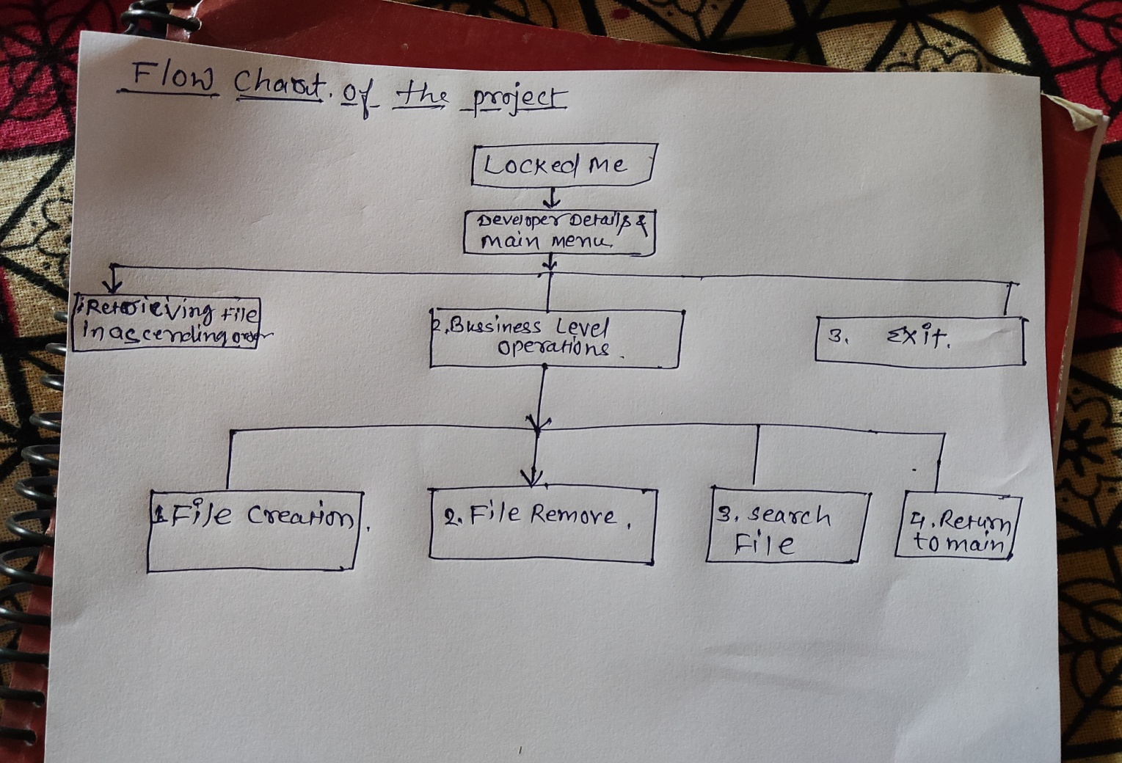

Goal of the project

**THE GOAL OF PROJECT TO EXPLORE PRODUCT OF COMPANY TO EVERYONE WITH LockedMe.com.**

**The goal of the company is to deliver a high-end quality product as early as possible**.

**USER STORY**

**TASK 1 -** Setting up Git and GitHub account

**TASK 2 -** Coding part of project appearance, and user interactions

**TASK 3 -** Generic features and three operations:

* + Retrieving the file names in an ascending order
  + Business-level operations:
    - Option to add a user specified file to the application
    - Option to delete a user specified file from the application
    - Option to search a user specified file from the application
    - Navigation option to close the current execution context and return to the main context
  + Option to close the application

**TASK 4 –** write up the Specification document .

**TASK 5**- complete the project and submit to the github account.

**Sprint**

**Day1: Task 1 it is completed.**

**Task2 Partially completed.**

**Task3 not started yet.**

**Task4 Partially completed.**

**Task5 not started yet.**

**Day2: Task 1 it is completed.**

**Task2 it is completed.**

**Task3 Partially completed.**

**Task4 Partially completed.**

**Task5 it is not completed.**

**Day3: Task 1 it is completed.**

**Task2 it is completed.**

**Task3 Partially completed.**

**Task4 Partially completed.**

**Task5 it is not completed.**

**Day4: Task 1 it is completed.**

**Task2 it is completed.**

**Task3 Partially completed.**

**Task4 Partially completed.**

**Task5 it is not completed.**

**Day5: Task 1 it is completed.**

**Task2 it is completed.**

**Task3 it is completed.**

**Task4 Partially completed**

**Task5 it is not completed.**

**Day6: Task 1 it is completed.**

**Task2 it is completed.**

**Task3 it is completed.**

**Task4 it is completed.**

**Task5 it is not completed.**

**Day7: Task 1 it is completed.**

**Task2 it is completed.**

**Task3 it is completed.**

**Task4 it is completed.**

**Task5 it is completed**

**Project objective:**

As a Full Stack Developer, complete the features of the application by planning the development in terms of sprints and then push the source code to the GitHub repository. As this is a prototyped application, the user interaction will be via a command line.

**Background of the problem statement:**

Company Lockers Pvt. Ltd. hired you as a Full Stack Developer. They aim to digitize their products and chose LockedMe.com as their first project to start with. You’re asked to develop a prototype of the application. The prototype of the application will be then presented to the relevant stakeholders for the budget approval. Your manager has set up a meeting where you’re asked to present the following in the next 15 working days (3 weeks):

* Specification document - Product’s capabilities, appearance, and user interactions
* Number and duration of sprints required
* Setting up Git and GitHub account to store and track your enhancements of the prototype
* Java concepts being used in the project
* Data Structures where sorting and searching techniques are used.
* Generic features and three operations:
* Retrieving the file names in an ascending order
* Business-level operations:
* Option to add a user specified file to the application
* Option to delete a user specified file from the application
* Option to search a user specified file from the application
* Navigation option to close the current execution context and return to the main context
* Option to close the application

**Technology used:**

* Eclipse: An IDE to code for the application
* Java: A programming language to develop the prototype
* Git: To connect and push files from the local system to GitHub
* GitHub: To store the application code and track its versions
* Scrum: An efficient agile framework to deliver the product incrementally
* Search and Sort techniques: Data structures used for the project
* Specification document: Any open-source document or Google Docs

**Requirements:**

* The source code should be pushed to your GitHub repository. You need to document the steps and write the algorithms in it.
* The submission of your GitHub repository link is mandatory. In order to track your task, you need to share the link of the repository. You can add a section in your document.
* Document the step-by-step process starting from sprint planning to the product release.
* Application should not close, exit, or throw an exception if the user specifies an invalid input.
* You need to submit the final specification document which includes:
  + Project and developer details
  + Sprints planned and the tasks achieved in them
  + Algorithms and flowcharts of the application
  + Core concepts used in the project
  + Links to the GitHub repository to verify the project completion
  + Your conclusion on enhancing the application and defining the USPs (Unique Selling Points)

### Features of the Project

* Code to display the welcome screen. It should display:
  + Application name and the developer details
  + The details of the user interface such as options displaying the user interaction information
  + Features to accept the user input to select one of the options listed
* The first option should return the current file names in ascending order. The root directory can be either empty or contain few files or folders in it
* The second option should return the details of the user interface such as options displaying the following:
  + Add a file to the existing directory list
    - You can ignore the case sensitivity of the file names
  + Delete a user specified file from the existing directory list
    - You can add the case sensitivity on the file name in order to ensure that the right file is deleted from the directory list
    - Return a message if FNF (File not found)
  + Search a user specified file from the main directory
    - You can add the case sensitivity on the file name to retrieve the correct file
    - Display the result upon successful operation
    - Display the result upon unsuccessful operation
  + Option to navigate back to the main context
* There should be a third option to close the application

### functionality

Generic features and three operations:

* Retrieving the file names in an ascending order
* Business-level operations:
  + Option to add a user specified file to the application
  + Option to delete a user specified file from the application
  + Option to search a user specified file from the application
  + Navigation option to close the current execution context and return to the main context
* Option to close the application